**Mobile Application Development**

**Lab Assignments 1-4**

1. **Android App Life Cycle**

MainActivity.java:

*package* com.example.lifecycle;

*import* androidx.appcompat.app.AppCompatActivity;

*import* android.os.Bundle;

*import* android.widget.Toast;

*public class* MainActivity *extends* AppCompatActivity {

@Override

*protected void* onCreate(Bundle savedInstanceState) {

*super*.onCreate(savedInstanceState);

setContentView(R.layout.*activity_main*);

Toast.*makeText*(getApplicationContext(), "Created", Toast.*LENGTH_SHORT*).show();

}

@Override

*protected void* onStart() {

*super*.onStart();

Toast.*makeText*(getApplicationContext(), "Started", Toast.*LENGTH_SHORT*).show();

}

@Override

*protected void* onResume() {

*super*.onResume();

Toast.*makeText*(getApplicationContext(), "Resumed", Toast.*LENGTH_SHORT*).show();

}

@Override

*protected void* onPause() {

*super*.onPause();

Toast.*makeText*(getApplicationContext(), "Paused", Toast.*LENGTH_SHORT*).show();

}

@Override

*protected void* onStop() {

*super*.onStop();

Toast.*makeText*(getApplicationContext(), "Stopped", Toast.*LENGTH_SHORT*).show();

}

@Override

*protected void* onRestart() {

*super*.onRestart();

Toast.*makeText*(getApplicationContext(), "Restarted", Toast.*LENGTH_SHORT*).show();

}

@Override

*protected void* onDestroy() {

*super*.onDestroy();

Toast.*makeText*(getApplicationContext(), "Destroyed", Toast.*LENGTH_SHORT*).show();

}

}

activity_main.xml:

<?*xml version*="1.0" *encoding*="utf-8"?>

<androidx.constraintlayout.widget.ConstraintLayout *xmlns:android*="http://schemas.android.com/apk/res/android"

*xmlns:app*="http://schemas.android.com/apk/res-auto"

*xmlns:tools*="http://schemas.android.com/tools"

*android:layout_width*="match_parent"

*android:layout_height*="match_parent"

*tools:context*=".MainActivity">

<TextView

*android:id*="@+id/textView"

*android:layout_width*="wrap_content"

*android:layout_height*="wrap_content"

*android:text*="Life Cycle App"

*android:textSize*="25sp"

*app:layout_constraintBottom_toBottomOf*="parent"

*app:layout_constraintLeft_toLeftOf*="parent"

*app:layout_constraintRight_toRightOf*="parent"

*app:layout_constraintTop_toTopOf*="parent"

*app:layout_constraintVertical_bias*="0.345" />

<Button

*android:id*="@+id/button"

*android:layout_width*="wrap_content"

*android:layout_height*="wrap_content"

*android:gravity*="center"

*android:text*="Button"

*app:layout_constraintBottom_toBottomOf*="parent"

*app:layout_constraintEnd_toEndOf*="parent"

*app:layout_constraintHorizontal_bias*="0.498"

*app:layout_constraintStart_toStartOf*="parent"

*app:layout_constraintTop_toTopOf*="parent"

*app:layout_constraintVertical_bias*="0.673" />

</androidx.constraintlayout.widget.ConstraintLayout>

Screenshots:

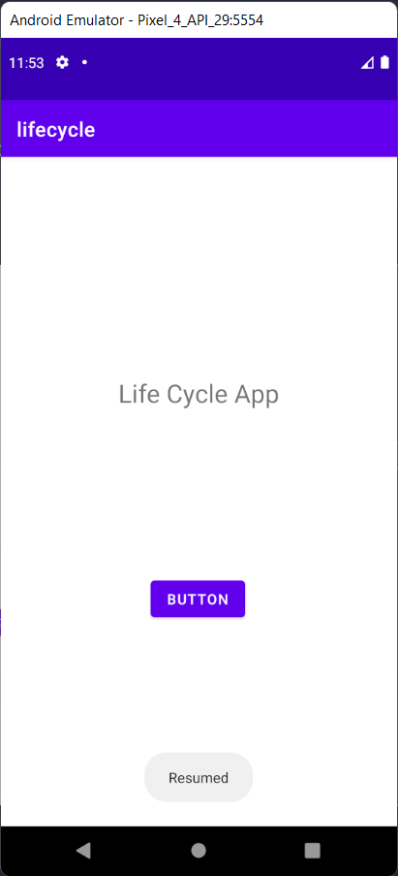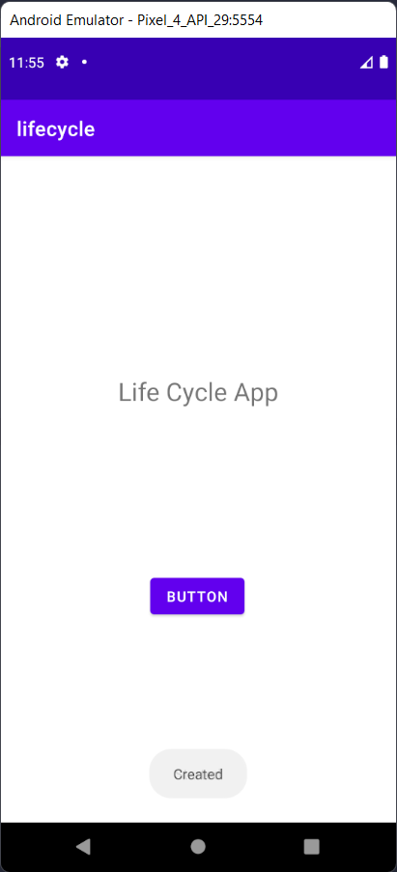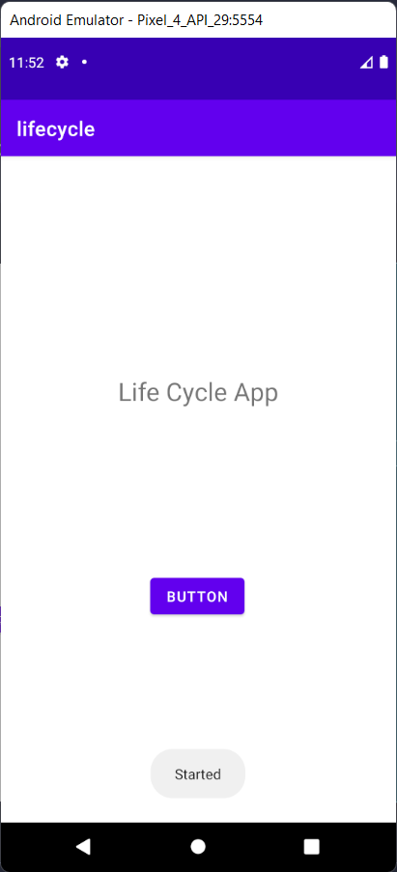

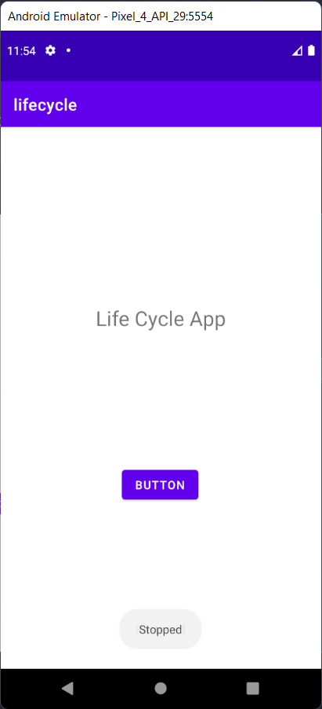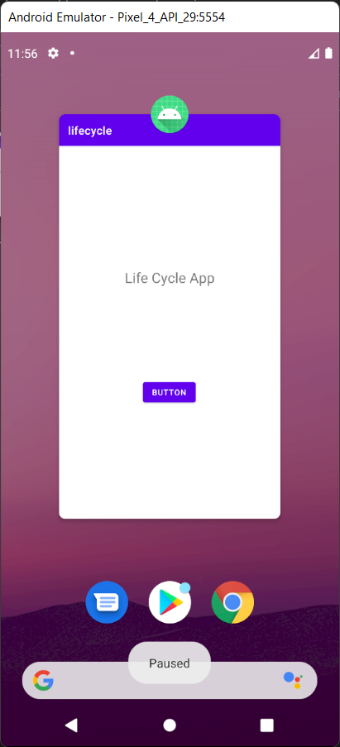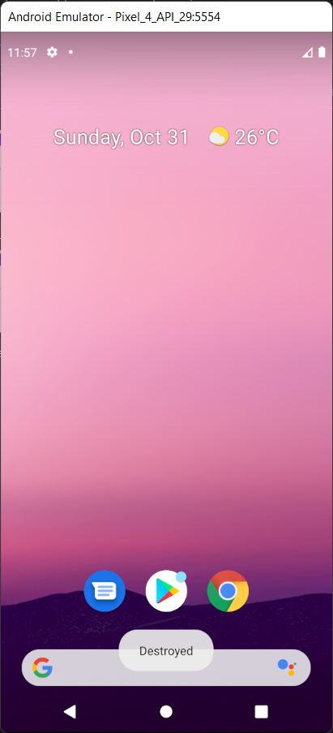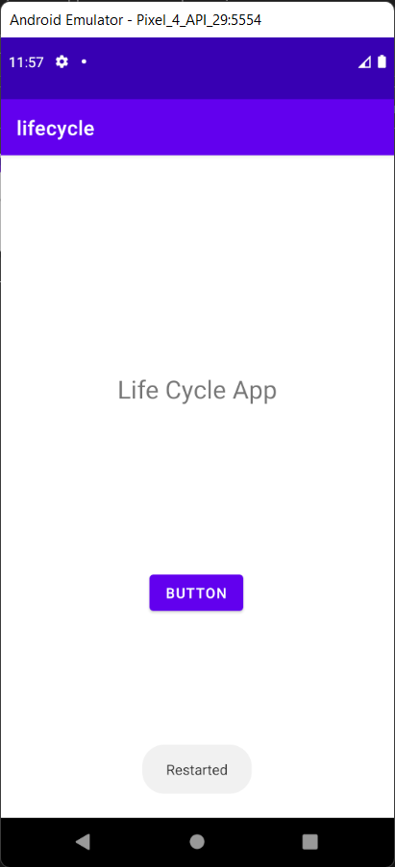

1. Linear Layout App - 1

MainActivity.java

*package* com.example.linearlayout;

*import* androidx.appcompat.app.AppCompatActivity;

*import* android.os.Bundle;

*import* android.view.View;

*import* android.widget.EditText;

*import* android.widget.Toast;

*public class* MainActivity *extends* AppCompatActivity {

@Override

*protected void* onCreate(Bundle savedInstanceState) {

*super*.onCreate(savedInstanceState);

setContentView(R.layout.*activity_main*);

}

*public void* showName(View view){

EditText edit = (EditText) findViewById(R.id.*editTextTextPersonName*);

String name = edit.getText().toString();

String res = "Hello "+name+", how are you!";

Toast.*makeText*(getApplicationContext(), res, Toast.*LENGTH_SHORT*).show();

}

}

activity_main.xml:

<?*xml version*="1.0" *encoding*="utf-8"?>

<LinearLayout *xmlns:android*="http://schemas.android.com/apk/res/android"

*android:layout_width*="match_parent"

*android:layout_height*="match_parent"

*android:layout_gravity*="center"

*android:orientation*="vertical"

*android:paddingLeft*="16dp"

*android:paddingRight*="16dp">

<TextView

*android:id*="@+id/textView"

*android:layout_width*="match_parent"

*android:layout_height*="wrap_content"

*android:layout_marginTop*="48dp"

*android:layout_marginBottom*="20dp"

*android:text*="Linear Layout App"

*android:textAlignment*="center"

*android:textColor*="@color/purple_700"

*android:textSize*="36dp" />

<LinearLayout

*android:layout_width*="match_parent"

*android:layout_height*="wrap_content"

*android:layout_gravity*="center"

*android:layout_marginVertical*="48dp"

*android:orientation*="horizontal"

*android:paddingLeft*="36dp"

*android:paddingRight*="36dp">

<TextView

*android:id*="@+id/textView2"

*android:layout_width*="wrap_content"

*android:layout_height*="wrap_content"

*android:layout_marginHorizontal*="12dp"

*android:layout_marginVertical*="36dp"

*android:text*="Name"

*android:textColor*="@color/design_default_color_secondary_variant"

*android:textSize*="24dp" />

<EditText

*android:id*="@+id/editTextTextPersonName"

*android:layout_width*="wrap_content"

*android:layout_height*="wrap_content"

*android:layout_marginVertical*="36dp"

*android:ems*="10"

*android:hint*="Enter you name"

*android:inputType*="textPersonName"

*android:paddingVertical*="10dp" />

</LinearLayout>

<Button

*android:id*="@+id/button"

*android:layout_width*="126dp"

*android:layout_height*="62dp"

*android:layout_gravity*="center"

*android:onClick*="showName"

*android:text*="Click Me" />

</LinearLayout>

Screenshots:

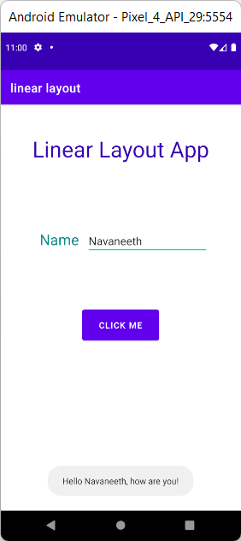

3) Linear layout App - 2 Calculator

MainActivity.java

*package* com.example.ll2_calculator;

*import* androidx.appcompat.app.AppCompatActivity;

*import* android.os.Bundle;

*import* android.view.View;

*import* android.widget.EditText;

*import* android.widget.Toast;

*public class* MainActivity *extends* AppCompatActivity {

@Override

*protected void* onCreate(Bundle savedInstanceState) {

*super*.onCreate(savedInstanceState);

setContentView(R.layout.*activity_main*);

}

*public void* add(View view)

{

EditText num1 = (EditText) findViewById(R.id.*editTextNumber3*);

EditText num2 = (EditText) findViewById(R.id.*editTextNumber4*);

*int* a = Integer.*parseInt*(num1.getText().toString());

*int* b = Integer.*parseInt*(num2.getText().toString());

*int* res = a+b;

Toast.*makeText*(getApplicationContext(), "Sum = "+res, Toast.*LENGTH_SHORT*).show();

}

*public void* sub(View view)

{

EditText num1 = (EditText) findViewById(R.id.*editTextNumber3*);

EditText num2 = (EditText) findViewById(R.id.*editTextNumber4*);

*int* a = Integer.*parseInt*(num1.getText().toString());

*int* b = Integer.*parseInt*(num2.getText().toString());

*int* res = a-b;

Toast.*makeText*(getApplicationContext(), "Difference = "+res, Toast.*LENGTH_SHORT*).show();

}

*public void* multiply(View view)

{

EditText num1 = (EditText) findViewById(R.id.*editTextNumber3*);

EditText num2 = (EditText) findViewById(R.id.*editTextNumber4*);

*int* a = Integer.*parseInt*(num1.getText().toString());

*int* b = Integer.*parseInt*(num2.getText().toString());

*int* res = a*b;

Toast.*makeText*(getApplicationContext(), "Product = "+res, Toast.*LENGTH_SHORT*).show();

}

*public void* divide(View view)

{

EditText num1 = (EditText) findViewById(R.id.*editTextNumber3*);

EditText num2 = (EditText) findViewById(R.id.*editTextNumber4*);

*float* a = Integer.*parseInt*(num1.getText().toString());

*float* b = Integer.*parseInt*(num2.getText().toString());

*float* res = a/b;

Toast.*makeText*(getApplicationContext(), "Quotient = "+res, Toast.*LENGTH_SHORT*).show();

}

}

Activity_main.xml

<?*xml version*="1.0" *encoding*="utf-8"?>

<LinearLayout *xmlns:android*="http://schemas.android.com/apk/res/android"

*android:layout_width*="match_parent"

*android:layout_height*="match_parent"

*android:paddingLeft*="16dp"

*android:paddingRight*="16dp"

*android:orientation*="vertical"

*android:layout_gravity*="center"

*android:layout_centerHorizontal*="true"

*android:layout_centerVertical*="true">

<TextView

*android:id*="@+id/textView4"

*android:layout_width*="match_parent"

*android:layout_height*="wrap_content"

*android:layout_marginTop*="24dp"

*android:gravity*="center"

*android:textSize*="36sp"

*android:textColor*="@color/purple_700"

*android:text*="Mini Calculator" />

<TextView

*android:id*="@+id/textView5"

*android:layout_width*="match_parent"

*android:layout_height*="wrap_content"

*android:layout_marginHorizontal*="75dp"

*android:layout_marginVertical*="24dp"

*android:gravity*="center"

*android:padding*="8sp"

*android:text*="Number 1"

*android:textAlignment*="center"

*android:textColor*="@color/purple_700"

*android:textSize*="20dp" />

<EditText

*android:id*="@+id/editTextNumber3"

*android:layout_width*="156dp"

*android:layout_height*="wrap_content"

*android:layout_gravity*="center"

*android:ems*="10"

*android:gravity*="center"

*android:inputType*="number"

*android:textAlignment*="center"

*android:textColor*="@color/black" />

<TextView

*android:id*="@+id/textView6"

*android:layout_width*="match_parent"

*android:layout_height*="wrap_content"

*android:layout_marginVertical*="24dp"

*android:layout_marginHorizontal*="75dp"

*android:padding*="8sp"

*android:gravity*="center"

*android:textSize*="20dp"

*android:textColor*="@color/purple_700"

*android:textAlignment*="center"

*android:text*="Number 2" />

<EditText

*android:id*="@+id/editTextNumber4"

*android:layout_width*="165dp"

*android:layout_height*="wrap_content"

*android:layout_gravity*="center"

*android:ems*="10"

*android:gravity*="center"

*android:inputType*="number"

*android:textColor*="@color/black" />

<LinearLayout

*android:layout_width*="382dp"

*android:layout_height*="wrap_content"

*android:layout_marginVertical*="20dp"

*android:orientation*="horizontal"

*android:paddingLeft*="16dp"

*android:paddingRight*="16dp">

<Button

*android:id*="@+id/button"

*android:layout_width*="117dp"

*android:layout_height*="65dp"

*android:layout_marginHorizontal*="20dp"

*android:layout_marginVertical*="24dp"

*android:gravity*="center"

*android:onClick*="add"

*android:text*="+" />

<Button

*android:id*="@+id/button7"

*android:layout_width*="117dp"

*android:layout_height*="65dp"

*android:layout_marginHorizontal*="36dp"

*android:layout_marginVertical*="24dp"

*android:onClick*="sub"

*android:text*="-" />

</LinearLayout>

<LinearLayout

*android:layout_width*="382dp"

*android:layout_height*="match_parent"

*android:paddingLeft*="16dp"

*android:paddingRight*="16dp"

*android:orientation*="horizontal"

*android:layout_marginVertical*="0dp">

<Button

*android:id*="@+id/button4"

*android:layout_width*="117dp"

*android:layout_height*="65dp"

*android:layout_marginHorizontal*="24dp"

*android:layout_marginVertical*="24dp"

*android:gravity*="center"

*android:text*="*"

*android:onClick*="multiply"/>

<Button

*android:id*="@+id/button5"

*android:layout_width*="117dp"

*android:layout_height*="65dp"

*android:layout_marginHorizontal*="30dp"

*android:layout_marginVertical*="24dp"

*android:text*="/"

*android:onClick*="divide"/>

</LinearLayout>

</LinearLayout>

Screenshots:

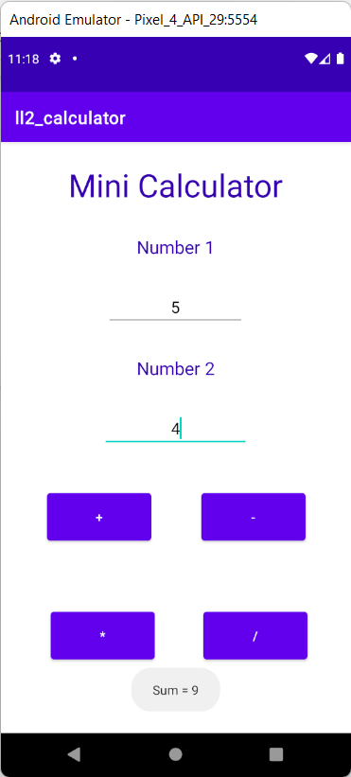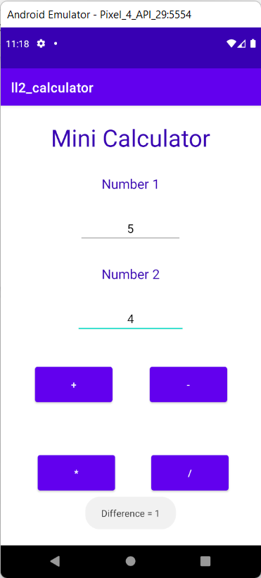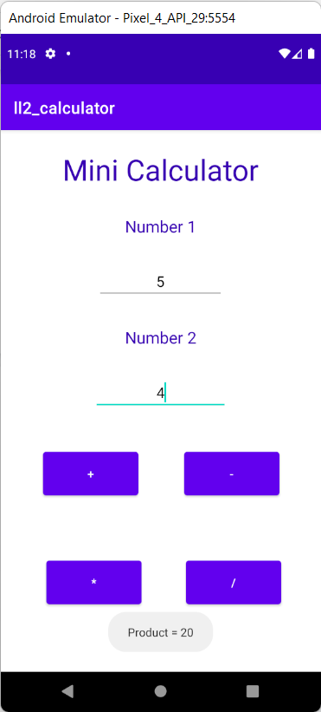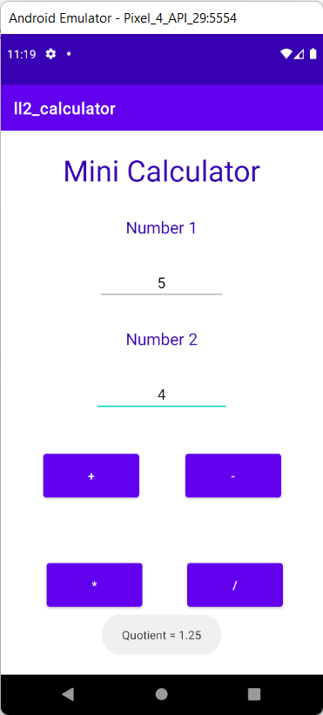

4) Relative Layout: Buttons

MainActivity.java:

*package* com.example.rlaayout1;

*import* androidx.appcompat.app.AppCompatActivity;

*import* android.os.Bundle;

*public class* MainActivity *extends* AppCompatActivity {

@Override

*protected void* onCreate(Bundle savedInstanceState) {

*super*.onCreate(savedInstanceState);

setContentView(R.layout.*activity_main*);

}

}

activity_main.xml:

<?*xml version*="1.0" *encoding*="utf-8"?>

<RelativeLayout *xmlns:android*="http://schemas.android.com/apk/res/android"

*android:layout_width*="match_parent"

*android:layout_height*="match_parent"

*android:paddingLeft*="10dp"

*android:paddingRight*="10dp">

<Button

*android:id*="@+id/btn1"

*android:layout_width*="wrap_content"

*android:layout_height*="wrap_content"

*android:layout_alignParentLeft*="true"

*android:layout_marginHorizontal*="10dp"

*android:text*="Button1" />

<Button

*android:id*="@+id/btn2"

*android:layout_width*="wrap_content"

*android:layout_height*="wrap_content"

*android:layout_alignParentRight*="true"

*android:layout_centerVertical*="true"

*android:text*="Button2" />

<Button

*android:id*="@+id/btn3"

*android:layout_width*="wrap_content"

*android:layout_height*="wrap_content"

*android:layout_alignParentLeft*="true"

*android:layout_centerVertical*="true"

*android:text*="Button3" />

<Button

*android:id*="@+id/btn4"*android:layout_width*="match_parent"

*android:layout_height*="wrap_content"

*android:layout_alignParentBottom*="true"

*android:text*="Button4" />

<Button

*android:id*="@+id/btn5"

*android:layout_width*="wrap_content"

*android:layout_height*="wrap_content"

*android:layout_alignBottom*="@+id/btn2"

*android:layout_centerHorizontal*="true"

*android:text*="Button5" />

<Button

*android:id*="@+id/btn6"

*android:layout_width*="wrap_content"

*android:layout_height*="wrap_content"

*android:layout_above*="@+id/btn4"

*android:layout_centerHorizontal*="true"

*android:text*="Button6" />

<Button

*android:id*="@+id/btn7"

*android:layout_width*="wrap_content"

*android:layout_height*="wrap_content"

*android:layout_alignParentRight*="true"

*android:layout_toEndOf*="@+id/btn1"

*android:layout_toRightOf*="@+id/btn1"

*android:text*="Button7" />

</RelativeLayout>

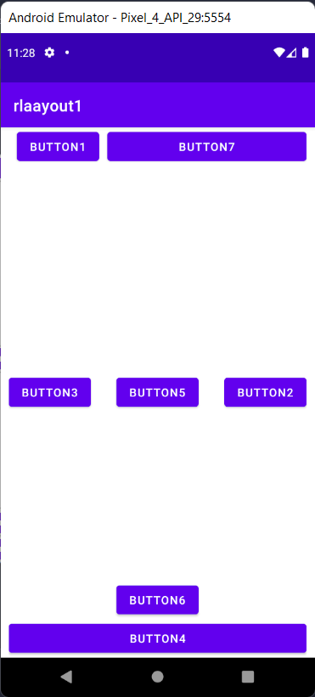

Screenshots:

5) Relative Layout: Course Registration

MainActivity.java:

*package* com.example.rlayout2;

*import* androidx.appcompat.app.AppCompatActivity;

*import* android.os.Bundle;

*import* android.view.View;

*import* android.widget.EditText;

*import* android.widget.Toast;

*public class* MainActivity *extends* AppCompatActivity {

@Override

*protected void* onCreate(Bundle savedInstanceState) {

*super*.onCreate(savedInstanceState);

setContentView(R.layout.*activity_main*);

}

*public void* submitForm(View view)

{

EditText cn = (EditText) findViewById(R.id.*editTextTextPersonName*);

EditText cid = (EditText) findViewById(R.id.*editTextTextPersonName2*);

EditText name = (EditText) findViewById(R.id.*editTextTextPersonName3*);EditText usn = (EditText) findViewById(R.id.*editTextTextPersonName4*);

String a = cn.getText().toString();

String b = cid.getText().toString();

String c = name.getText().toString();

String d = usn.getText().toString();

String res = "Course Name : "+a + "\nCourse Code : "+b +"\nName : "+c + "\nUSN : "+d;

Toast.*makeText*(getApplicationContext(), res, Toast.*LENGTH_LONG*).show();

}

}

Activity_main.xml:

<?*xml version*="1.0" *encoding*="utf-8"?>

<RelativeLayout *xmlns:android*="http://schemas.android.com/apk/res/android"

*android:layout_width*="match_parent"

*android:layout_height*="match_parent"

*android:paddingLeft*="10dp"

*android:paddingRight*="10dp"

*android:layout_marginVertical*="36dp"

>

<EditText

*android:id*="@+id/editTextTextPersonName"

*android:layout_width*="161dp"

*android:layout_height*="wrap_content"

*android:layout_marginHorizontal*="10dp"

*android:layout_marginVertical*="20dp"

*android:ems*="10"

*android:hint*="Course Name"

*android:inputType*="textPersonName" />

<EditText

*android:id*="@+id/editTextTextPersonName2"

*android:layout_width*="184dp"

*android:layout_height*="wrap_content"

*android:layout_alignParentRight*="true"

*android:layout_marginHorizontal*="10dp"

*android:layout_marginVertical*="20dp"

*android:layout_marginRight*="14dp"

*android:ems*="10"

*android:hint*="Course Code"

*android:inputType*="textPersonName" />

<EditText

*android:id*="@+id/editTextTextPersonName3"

*android:layout_width*="wrap_content"

*android:layout_height*="wrap_content"

*android:layout_alignBottom*="@+id/editTextTextPersonName2"

*android:layout_centerInParent*="true"

*android:layout_marginBottom*="-108dp"

*android:ems*="10"

*android:hint*="Enter Name"

*android:inputType*="textPersonName" />

<EditText

*android:id*="@+id/editTextTextPersonName4"

*android:layout_width*="wrap_content"

*android:layout_height*="wrap_content"

*android:layout_alignBottom*="@+id/editTextTextPersonName3"

*android:layout_centerHorizontal*="true"

*android:layout_marginBottom*="-111dp"

*android:ems*="10"

*android:inputType*="textPersonName"

*android:hint*="Enter USN" />

<Button

*android:id*="@+id/button"

*android:layout_width*="202dp"

*android:layout_height*="78dp"

*android:layout_alignParentBottom*="true"

*android:layout_centerInParent*="true"

*android:layout_marginBottom*="219dp"

*android:onClick*="submitForm"

*android:text*="Submit Form" />

</RelativeLayout>

Screenshots:

